Pack 618 Bike Hike
From Lake Elkhorn To Savage Park
April 26, 2008

This year, the Bike Hike will start at Lake Elkhorn and follow the bike path under Broken Land Parkway and beyond, all the way to Savage Park. This trail is called the “Patuxent Branch Trail”. We will meet at Lake Elkhorn near the tunnel (between the dam and Broken Land Parkway) for a 9:30 AM start time.

There is parking in a small lot along Broken Land Parkway, along Cradlerock way (next to playground) and in a parking lot at the end of Dockside Lane. There are parking lots across Broken Land Parkway also. (See Figure 1, the arrows indicate parking areas)

The one-way trip is approximately 5 miles. We ask that each rider be outfitted with enough water for the trip. We will have bottled water available at the starting point and at the park. Bring snacks to keep your energy up during the ride.

We intend to have someone with a van take all lunches to the park so that the riders will have their lunches available when they arrive. Participants are responsible for bringing their own lunch and snacks. We will load the lunches into shuttle-van prior to the bike hike. (Any volunteers?)

We will also need adults on the trip to take the First-Aid kit in case of mishap. Additionally, an adult will need to trail the pack to make sure that we don’t lose anyone. Those willing to fulfill these roles, please identify yourselves prior to the beginning of the trip.

The hike ends at Savage Park, at the baseball fields/tennis courts area. (See Figure 2) We will eat our lunches there. Bottled water will be available.

Bikers wishing to do so will return to Lake Elkhorn after lunch.

The Bike Hike is being organized and led by Mr. Jason Carlisi this year. Please give him your full support (and a pat on the back!) the day of the event.

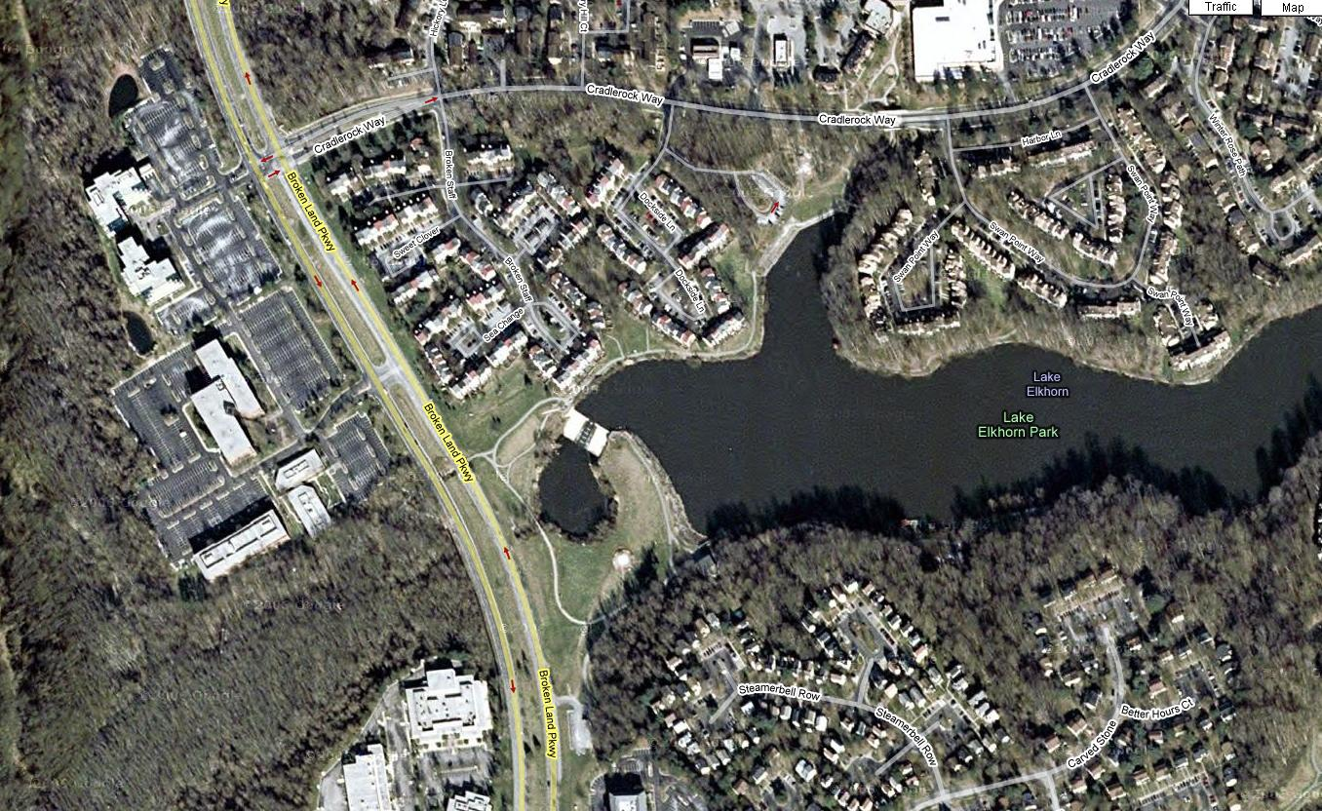
Figure 1
Lake Elkhorn Parking
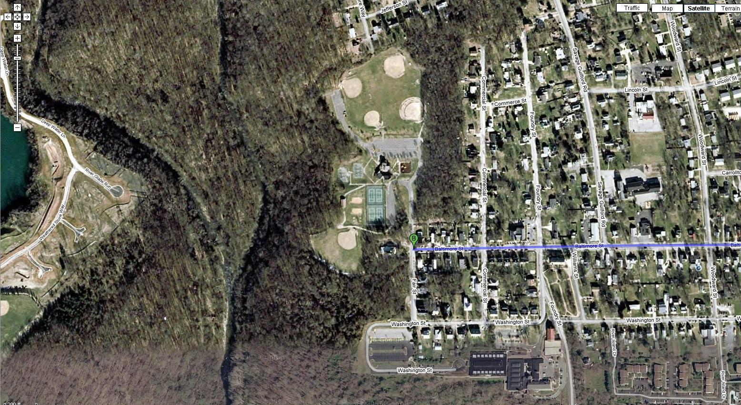
Figure 2
Savage Park Meeting Area

Here’s some info from Trails.com

